


BSc Hons Computer Science with Software Engineering
2026.1
Programming, Data Structures and Algorithms
(Title)

Coventry Index : 17719731
NIBM Registered Name : B.R.D.M.Senevirathne

Faculty of Engineering, Environment and Computing
School of Computing, Electronics and Mathematics
Coventry University
School of Computing and Engineering
National Institute of Business Management

Table of Contents
(Table of contents – right-click and choose "Update Field", or press Ctrl+A then F9, to generate page numbers.)

Chapter 1 – Introduction
Learning Outcome Mapping | LO1 | LO2 | LO3
 |  |  | ✓

1.1 Background
SmartLogix is an e-commerce platform built around a single promise: a buyer orders a product, and a drone flies it to them from whichever warehouse actually has it in stock. When several ready orders from the same warehouse fall inside the same delivery zone at roughly the same time, it is wasteful to send one drone per order — the warehouse instead consolidates them onto a single drone flight that visits every drop point once and returns to the warehouse to recharge and load the next batch. The question this raises is: in what order should the drone visit the stops in a batch, so the whole trip — and the battery it spends — is as short as possible?
Stripped of the delivery framing, this is the (symmetric) Travelling Salesperson Problem (TSP): given a depot and a set of stops, find the shortest closed tour that visits every stop exactly once and returns to the depot. It is one of the most-studied problems in computer science precisely because it is NP-hard — no known algorithm solves it exactly in polynomial time, and every exact method's running time explodes combinatorially as the number of stops grows. Within our team, I took ownership of this piece — the Batch Delivery Route module — corresponding to Task 5 of the assignment: analyse an intractable optimization problem, implement a heuristic (Simulated Annealing) and the data structures that support it (a circularly linked list and a 2D distance array), integrate the result, and evaluate it with experimental evidence.

1.2 Objectives
The objectives I set for this individual contribution were to:
• Analyse the multi-stop batch-delivery routing problem and establish precisely why it is computationally intractable, rather than asserting NP-hardness without demonstrating it.
• Investigate exact, heuristic and approximation algorithms for the Travelling Salesperson Problem, and understand what each one trades away to cope with intractability.
• Compare the candidates on solution quality, computational efficiency and scalability, at the batch sizes SmartLogix's drones actually fly rather than at an arbitrary scale.
• Select Simulated Annealing and justify the choice with evidence.
• Design a circularly linked list and a 2D distance matrix that fit how the heuristic actually manipulates a tour — an O(1) adjacent-node swap, looked up against precomputed pairwise distances.
• Implement the module and integrate it as a genuine, importable piece of the SmartLogix codebase.
• Analyse the time and space complexity of the implementation as written.
• Evaluate the module against a true optimum where one is computable (brute force, small batches) and against nearest-neighbour and 2-opt heuristics at larger batch sizes, and report the results honestly, including where Simulated Annealing's quality degrades.
• Recommend concrete next steps for the module.

1.3 Scope of Individual Contribution
My contribution is the Batch Delivery Route module at src/lib/dsa/simulated-annealing.ts. Concretely, this covers: distance(), the same Haversine great-circle calculation used elsewhere in SmartLogix's routing code; buildDistanceMatrix(), which precomputes every pairwise distance between the depot and the batch's delivery stops into a 2D array; CircularTour and TourNode, a circularly linked list representation of a closed tour with an O(1) swapWithNext() operation; and simulatedAnnealingTSP(), the Simulated Annealing search itself, which returns an ordered delivery route, its total distance, the iteration count, and a convergence history used for the evaluation in Chapter 8.
I want to be precise about where this stops. The module is implemented, type-checked and benchmarked against a real dataset, but at the time of writing it is not yet called from any page — there is no UI flow yet where a warehouse operator selects a cluster of ready orders and triggers this module. Wiring a small “batch this order in” affordance into the existing order/warehouse admin views is the natural next step, and I come back to it explicitly in the recommendations in Chapter 9 rather than implying the integration is further along than it is.

1.4 Organization of the Report
Chapter 2 analyses the batch-delivery routing problem and demonstrates its intractability. Chapter 3 investigates exact, heuristic and approximation algorithms for the Travelling Salesperson Problem, with a comparative analysis. Chapter 4 justifies the choice of Simulated Annealing against the alternatives. Chapter 5 covers the circularly linked list and 2D distance matrix. Chapter 6 presents the detailed algorithm design, including a flowchart, pseudocode and a worked example over a real eight-stop batch. Chapter 7 analyses the complexity of the code as it stands. Chapter 8 evaluates the module experimentally against a true optimum where computable, and against alternative heuristics at scale. Chapter 9 critically evaluates the solution and recommends improvements. Chapter 10 is a personal reflection on my individual contribution. Chapter 11 concludes the report.

Chapter 2 – Problem Analysis
Learning Outcome Mapping | LO1 | LO2 | LO3
 |  | ✓ | ✓

2.1 Problem Definition
Formally: given a depot d and a set of n delivery stops S = {s1, …, sn}, each pair connected by a symmetric distance (Haversine great-circle distance between coordinates), find a permutation of S that minimises the total length of the closed tour d → sπ(1) → sπ(2) → … → sπ(n) → d. This is the classic symmetric Travelling Salesperson Problem, applied here to one drone's batch of consolidated orders rather than to a whole delivery region — the depot is the fixed warehouse the batch departs from and returns to, and the “cities” are the drop points already assigned to that flight.

2.2 Functional Requirements
• Given a depot and a batch of delivery stops, return an ordering of the stops that keeps the total closed-tour distance low.
• Support batches of the size a single drone can realistically carry in one flight (SmartLogix's drones are payload- and range-limited, so a batch is realistically a handful to around fifteen stops, not hundreds).
• Return the result as an ordered route plus its total distance, so the caller can render it and compare it against the drone's remaining battery/range budget.
• Behave predictably (bounded time) even though the underlying problem has no polynomial-time exact solution — the module must return an answer within a UI-appropriate time budget rather than searching indefinitely for a proof of optimality.

2.3 Inputs and Outputs
Inputs: a depot record (id, latitude, longitude) and a list of delivery-stop records (id, latitude, longitude) already assigned to one drone flight; optional Simulated Annealing parameters (initial temperature, cooling rate, minimum temperature, iterations per temperature step, random seed). Outputs: an ordered array of stops representing the tour (depot-relative, to be read as a closed loop back to the first element), the tour's total distance, the number of search iterations performed, and a convergence history (best-known length sampled once per temperature step) used for the evaluation in Chapter 8. Chapter 6 gives the exact function signatures.

2.4 Constraints
• Distances are symmetric and non-negative — the drone takes the same physical path length in either direction between two points, so the TSP instance here is the symmetric variant, not the harder asymmetric one.
• The module has to return an answer in bounded time regardless of batch size, which rules out any exact method whose running time is not bounded by a fixed, predictable budget.
• The batch composition (which orders are consolidated together) is decided upstream of this module — the module only orders an already-chosen set of stops, it does not decide which orders to batch together.
• A drone's payload and flight-range limits mean a batch is realistically small (roughly 5-15 stops); the module's design should be judged primarily against that realistic scale, not an arbitrarily large one.

2.5 Assumptions
• Haversine great-circle distance is an acceptable proxy for flight distance between two points, consistent with how distance is already computed elsewhere in the SmartLogix codebase.
• The distance metric satisfies the triangle inequality (a property of great-circle distance), which is what makes approximation algorithms such as Christofides' (Section 3.6) applicable in principle, even though this module does not implement it.
• A fixed Simulated Annealing schedule (the same initial temperature, cooling rate and iteration budget for every batch) is an acceptable starting point; Chapter 8's evaluation tests this assumption directly and Chapter 9 revisits it.

2.6 Computational Challenges: Demonstrating Intractability
The Travelling Salesperson Problem is NP-hard: no algorithm is known that finds the guaranteed-optimal tour in time polynomial in n, and the problem is at least as hard as any problem in NP. Two exact strategies illustrate why this matters in practice rather than only in theory:
• Brute force examines every possible ordering of the stops. Fixing the depot's position removes the tour's n-fold rotational symmetry, leaving (n − 1)! distinct orderings to check (or (n − 1)!/2 if the two traversal directions are also de-duplicated). For n = 10 that is 362,880 orderings — trivial; for n = 20 it is 121,645,100,408,832,000 — utterly infeasible.
• Held-Karp dynamic programming improves on brute force by reusing overlapping subproblems, reducing the time complexity to O(n² · 2ⁿ). This is a real improvement — for n = 20, 2²⁰ ≈ 1.05 million versus brute force's ~10¹⁷ — but it is still exponential: doubling n roughly squares the state space, and the O(2ⁿ) space requirement alone becomes prohibitive well before time does.
Section 8.2 measures brute force directly (up to n = 10, where it is still fast) precisely to make this intractability concrete rather than asserted: the measured brute-force time in Table 8.1 grows visibly faster than every other quantity in this report, which is the point — it is what motivates using a heuristic at all.

2.7 Characteristics of the Problem
This is a symmetric, metric (triangle-inequality-respecting), single-depot Travelling Salesperson instance, solved once per drone-flight batch rather than continuously, over a small n bounded by physical payload/range limits rather than by database size. It is not an all-pairs problem and not a problem with negative or asymmetric costs. These characteristics matter directly for algorithm selection in Chapters 3 and 4: they rule out exact methods at realistic scale, but they also mean the “realistic scale” a heuristic has to perform well at is genuinely small, which shapes the evaluation in Chapter 8.

2.8 Why a Heuristic and Suitable Data Structures Matter Here
Because no exact algorithm is usable beyond a handful of stops (Section 2.6), some form of heuristic or approximation is not an optional efficiency improvement here — it is the only way the module can return an answer at all once a batch exceeds about a dozen stops. And because the heuristic's inner loop runs tens of thousands of times per call (Chapter 7), the cost of a single neighbour move has an outsized effect on total running time — which is exactly why the data-structure choice in Chapter 5 (an O(1) adjacent swap on a circularly linked list, against an O(1)-lookup precomputed distance matrix) is not a minor implementation detail but the thing that makes the chosen algorithm practical at all.

Chapter 3 – Investigation of Candidate Algorithms
Learning Outcome Mapping | LO1 | LO2 | LO3
 | ✓ | ✓

This chapter investigates six candidate algorithms for the Travelling Salesperson Problem across the three families the assignment asks for — exact, heuristic and approximation.

3.1 Brute-Force Search (Exact)
Working principle: enumerate every possible ordering of the delivery stops and keep the shortest.
Advantages: guaranteed optimal; trivial to implement and verify.
Limitations: factorial time — completely infeasible beyond roughly a dozen stops (Section 2.6).
Computational complexity: O(n!) time.
Memory requirements: O(n) for the current permutation and the best-found route.
Suitability: usable only as a ground-truth check at small n (Chapter 8), never as the shipped algorithm.

3.2 Held-Karp Dynamic Programming (Exact)
Working principle: build up the optimal cost of visiting every subset of stops ending at each possible last stop, reusing overlapping subproblems (Held and Karp, 1962; Bellman, 1962).
Advantages: exact, and asymptotically far better than brute force.
Limitations: still exponential — the 2ⁿ subsets dominate both time and memory, so it remains infeasible for anything beyond roughly 20-25 stops.
Computational complexity: O(n² · 2ⁿ) time.
Memory requirements: O(n · 2ⁿ) — the memory bound is usually the first one exceeded in practice.
Suitability: better than brute force but still not usable at any batch size where a heuristic would otherwise be needed; not implemented in this module for that reason.

3.3 Nearest-Neighbour Construction (Heuristic)
Working principle: starting at the depot, repeatedly travel to the closest unvisited stop until all stops are visited, then return to the depot.
Advantages: extremely fast, simple to implement, always produces a valid tour.
Limitations: myopic — an early greedy choice can strand a distant stop for a very expensive final leg. It is a construction heuristic, not a search: it never revisits or improves a decision once made.
Computational complexity: O(n²) (checking the remaining stops at each of n steps).
Memory requirements: O(n).
Suitability: good as a fast baseline and as a starting tour for a local-search method, but not reliable enough to ship on its own — Chapter 8 measures it landing up to 27% above the true optimum on some instances.

3.4 Simulated Annealing (Heuristic / Metaheuristic)
Working principle: start from an initial tour and repeatedly propose a small random change (here, swapping two adjacent stops in the tour); always accept an improving change, and accept a worsening change with probability e^(−Δ/T), where Δ is the increase in tour length and T is a “temperature” that is gradually lowered over the search (Kirkpatrick, Gelatt and Vecchi, 1983).
Advantages: unlike nearest-neighbour, it can escape local minima by deliberately accepting some worse moves early on, when T is high; unlike brute force or Held-Karp, its running time is controlled directly by the iteration schedule rather than by n, so it stays within a predictable time budget at any batch size.
Limitations: it is a heuristic, not an exact method — it offers no guarantee of finding the optimum, and its result quality depends on the move set and the cooling schedule, both of which have to be tuned; Chapter 8 shows this concretely.
Computational complexity: O(1) per candidate move when the move only touches a constant number of edges (Chapter 5), so O(iterations) overall for the search, plus O(n²) once for the distance matrix.
Memory requirements: O(n) for the tour plus O(n²) for the precomputed distance matrix.
Suitability: very good at the batch sizes this module is actually used for (Chapter 8 shows it matching the true optimum exactly for every ground-truth batch tested, n = 5-10); its quality degrades at larger n under the current fixed iteration schedule, which Chapter 9 discusses as a specific, measured limitation rather than a reason to abandon the approach.

3.5 2-opt Local Search (Approximation / Local Search)
Working principle: starting from an initial tour, repeatedly look for a pair of edges whose removal and reconnection (reversing the segment between them) shortens the tour, until no such improving pair remains.
Advantages: a much stronger move than a single adjacent swap — it can undo a crossed-over route in one step — and it reliably converges to a good local optimum.
Limitations: each improving move costs O(n) to apply (reversing a segment of the tour) rather than the O(1) an adjacent swap costs, and a full pass to find an improving pair is O(n²); it also stops at the first local optimum it reaches, with no mechanism to escape it the way Simulated Annealing's uphill acceptance can.
Computational complexity: O(n²) per improvement pass, run until no improving move is found.
Memory requirements: O(n).
Suitability: very good in this investigation's own benchmarks (Chapter 8) — in fact the strongest performer at larger batch sizes — and is the clearest concrete alternative to Simulated Annealing recommended in Chapter 9.

3.6 Christofides' Algorithm (Approximation)
Working principle: build a minimum spanning tree over the stops, find a minimum-weight perfect matching over the tree's odd-degree vertices, combine them into a multigraph with an Eulerian circuit, then shortcut repeated visits into a Hamiltonian tour (Christofides, 1976).
Advantages: for metric instances (Section 2.5) it carries a proven worst-case guarantee — the resulting tour is never more than 1.5× the true optimum, which none of the other heuristics here can promise.
Limitations: substantially more complex to implement correctly (it needs a minimum-weight perfect matching algorithm, itself a non-trivial graph algorithm) than any other candidate here, for a worst-case guarantee that is looser than what Simulated Annealing and 2-opt already achieve in practice on this module's instances (Chapter 8).
Computational complexity: dominated by the minimum-weight perfect matching step, O(n³) with standard algorithms.
Memory requirements: O(n²) for the intermediate graphs.
Suitability: theoretically attractive for its guarantee, but not implemented here — I investigated it and ruled it out on implementation-cost grounds, the same way contraction hierarchies were investigated and ruled out in the companion Route Optimization module's report, not because it is a poor algorithm.

3.7 Comparative Analysis
The table below compares all six candidates against solution quality, time complexity, memory and ease of implementation, judged specifically against this module's realistic scale (batches of roughly 5-15 stops, one depot, a bounded time budget per call).
Algorithm | Solution quality | Time complexity | Space complexity | Ease of implementation | Fit for this scale
Brute force | Optimal | O(n!) | O(n) | Trivial | Only usable as a ground-truth check, n ≲ 10
Held-Karp DP | Optimal | O(n² · 2ⁿ) | O(n · 2ⁿ) | Moderate | Better, but still infeasible beyond ~20-25 stops
Nearest-neighbour | Weak (up to ~27% above optimal here) | O(n²) | O(n) | Trivial | Good baseline / SA starting tour, not a standalone answer
Simulated Annealing | Optimal at realistic batch sizes; degrades at large n (current schedule) | O(iterations), O(1)/move | O(n²) | Moderate | Very good at n = 5-15, the module's real use case
2-opt local search | Strong, best of the three heuristics at larger n | O(n²) per pass | O(n) | Moderate | Very good, the leading alternative (Chapter 9)
Christofides | Proven ≤1.5× optimal (metric instances) | O(n³) | O(n²) | Complex | Attractive guarantee, not worth its implementation cost yet

Simulated Annealing and 2-opt are the two genuinely competitive candidates once brute force and Held-Karp are ruled out by intractability and Christofides is ruled out by implementation cost relative to its benefit here. Which of the two is actually better is not obvious from complexity alone — Chapter 8 measures both directly rather than assuming.

Chapter 4 – Algorithm Selection and Justification
Learning Outcome Mapping | LO1 | LO2 | LO3
 |  | ✓ | ✓

4.1 Selected Algorithm
I implemented Simulated Annealing as the core of the module, using adjacent-node swaps as the neighbour move and a fixed geometric cooling schedule, as specified by the assignment brief and reflected in the module's implementation.

4.2 Reasons for Selection
• It is the algorithm the assignment specifies for this task, and it is a genuinely defensible choice on its own merits: it directly addresses the intractability identified in Chapter 2 by trading a guarantee of optimality for a fixed, predictable time budget.
• Its uphill-acceptance mechanism gives it a real, demonstrable advantage over nearest-neighbour alone: Chapter 8 shows it reaching the true optimum on every ground-truth batch tested, where nearest-neighbour does not.
• Its neighbour move (an adjacent swap) pairs naturally with a circularly linked list representation, giving an O(1) move cost that keeps the search's total running time predictable and independent of how the move is represented (Chapter 5).

4.3 Comparison with Alternative Approaches
Brute force and Held-Karp were ruled out because they are exact methods for an NP-hard problem — both are exponential, and Chapter 2 and Chapter 8 both demonstrate this directly rather than by assertion. Christofides was ruled out on implementation-cost grounds: its 1.5× worst-case guarantee is real, but it needs a minimum-weight perfect matching subroutine that is substantially more work to implement correctly than the benefit it adds over what Simulated Annealing and 2-opt already achieve on this module's actual instances. 2-opt was not ruled out — it is a genuine alternative, and Chapter 8's results argue for revisiting it (Chapter 9), but it was not the algorithm specified for this task and its natural move (segment reversal) does not have the same O(1) cost on a simple circularly linked list that an adjacent swap does, which is a real implementation trade-off against the data structures set out in Chapter 5.

4.4 Trade-offs Considered
The central trade-off is move strength versus move cost. An adjacent swap is the cheapest possible move on a circularly linked list (O(1)), but it is also the weakest — it can only ever change the relative order of two neighbouring stops, so untangling a badly crossed tour can take many more such moves than a single 2-opt segment reversal would need. Chapter 8's large-batch results are a direct, measured consequence of this trade-off: at n = 5-15 there are few enough stops that repeated adjacent swaps still reliably find the optimum within the fixed iteration budget; at n = 50-65 they do not. I chose to accept this trade-off because the realistic batch size for a single drone flight is small (Section 2.4), not because the trade-off is free at every scale.

4.5 Suitability and Expected Performance
Simulated Annealing over adjacent swaps is well suited to this problem's actual characteristics: a small, metric, single-depot TSP instance solved once per batch. At SmartLogix's realistic batch sizes, the expected result is at or extremely close to optimal, which Chapter 8 confirms directly against brute force.

4.6 Scalability Considerations
The current implementation uses a fixed iteration budget (a constant initial temperature, cooling rate and iterations-per-temperature-step) regardless of batch size. This is appropriate at the realistic scale this module targets, but Chapter 8 shows it becoming a real limitation well before batch sizes reach anything a single drone could carry — the measured degradation at n = 20-65 is a property of the fixed schedule, not of Simulated Annealing as a method. Scaling the iteration budget with n, or switching to 2-opt-style moves for larger batches, are the two concrete options I return to in Chapter 9.

Chapter 5 – Data Structure Selection and Design
Learning Outcome Mapping | LO1 | LO2 | LO3
 | ✓ | ✓

5.1 Circularly Linked List (the Tour)
Description: the tour is represented as a doubly linked, circular list of TourNode objects — each node holds one stop and next/prev pointers; the last node's next points back to the first, so the structure has no beginning or end, matching a closed delivery loop exactly.

class TourNode { stop: Stop; next: TourNode; prev: TourNode }
class CircularTour { head: TourNode | null; size: number; ... }

Justification: a delivery route that returns to its starting depot is, structurally, a cycle — a circularly linked list is the direct representation of a cycle, with no need to special-case the first or last stop, and no modulo arithmetic to wrap an array index around when the search reaches the “end” of the tour. The one operation the heuristic performs millions of times over a search (Chapter 7) — swapping two adjacent stops — is answered by relinking exactly four pointers (swapWithNext(), Section 5.4), touching nothing else in the structure.

5.2 Alternative Considered: Array Representation
An array of stops (with index arithmetic mod n to wrap around) was the natural alternative. Advantages: better cache locality, and swapping two elements by index is also O(1) in an array. Disadvantages: every neighbour lookup needs an explicit (i + 1) % n / (i − 1 + n) % n computation rather than a plain pointer dereference, and — more importantly for how this module might grow — inserting or removing a stop from an array-represented tour (for example, if a batch's composition changes after the search has started) is O(n), while it is O(1) on a linked list once the neighbouring nodes are known. I chose the circularly linked list because it matches the problem's natural cyclic structure directly and keeps the dominant operation (adjacent swap) free of index arithmetic, at the acknowledged cost of worse cache locality than a flat array — a reasonable trade at the small n this module targets (Section 2.4), and one I revisit explicitly in Section 5.4.

5.3 2D Distance Matrix
Description: an (n + 1) × (n + 1) array (depot plus n delivery stops) where matrix[i][j] holds the precomputed Haversine distance between stop i and stop j, built once per call by buildDistanceMatrix() before the search begins.
Justification: the search evaluates a candidate move by looking up the (at most) four edges touching the two nodes being swapped (Section 6.2) — tens of thousands of times over a single call (Chapter 7). Recomputing a Haversine distance on every lookup would mean repeating the same trigonometric calculation for the same pair of points thousands of times over; precomputing the full matrix once turns every subsequent lookup into a single O(1) array access.
Alternative considered: a hash map keyed by a composite “i,j” string, computed lazily on first lookup. Advantages: only pays for the pairs actually looked up, which matters if n is very large and the search only ever touches a small fraction of all pairs. Disadvantages: a string-keyed hash lookup carries real per-access overhead compared with a plain 2D array index, and — because the adjacent-swap move only ever needs distances between neighbouring stops in the current tour — the search in practice ends up looking up a large fraction of all pairs anyway over a full run, so the lazy approach saves little while costing more per access. I chose the plain 2D array because n is always small here (Section 2.4), so the full O(n²) matrix is cheap to build and the fastest structure to read from.

5.4 Impact on Algorithm Performance and Memory
Together, these two structures give the search loop's dominant per-iteration cost — evaluating and applying one candidate move — a small constant number of pointer dereferences and array reads: swapWithNext() relinks exactly four TourNode pointers, and the cost delta of a swap is four matrix[][] lookups plus a handful of additions (Section 6.2). Neither operation touches any structure whose size depends on how far into the search the algorithm has progressed, which is what keeps a single iteration O(1) regardless of tour length. Memory is O(n) for the tour (n + 1 TourNode objects) plus O(n²) for the distance matrix, which dominates at larger n — Chapter 7 and Chapter 8 both note this as the practical ceiling on batch size well before the search's own iteration cost becomes the bottleneck.

5.5 Relationship Between Algorithm and Data Structure Choices
The choice of neighbour move and the choice of tour representation were made together, not independently: an adjacent swap is only O(1) because the tour is a linked list rather than an array needing a segment shift, and a linked list only makes sense as a tour representation because the search's move is local (touching neighbouring nodes) rather than global (as 2-opt's segment reversal is, Section 3.5). This is precisely why 2-opt is not a drop-in replacement within the current data structures (Section 4.3) — adopting it would mean either accepting an O(n) reversal cost on the linked list or moving to an array representation better suited to that move, which is exactly the kind of joint algorithm/data-structure decision Chapter 9 discusses as a genuine option rather than a free upgrade.

Chapter 6 – Algorithm Design
Learning Outcome Mapping | LO1 | LO2 | LO3
 |  |  | ✓

6.1 Flowchart
Figure 6.1 shows the full control flow of simulatedAnnealingTSP(): building the distance matrix and the initial circular tour, the outer cooling loop, the inner per-temperature trial loop, the O(1) move-evaluation and accept/reject step, and the final return of the best tour found.
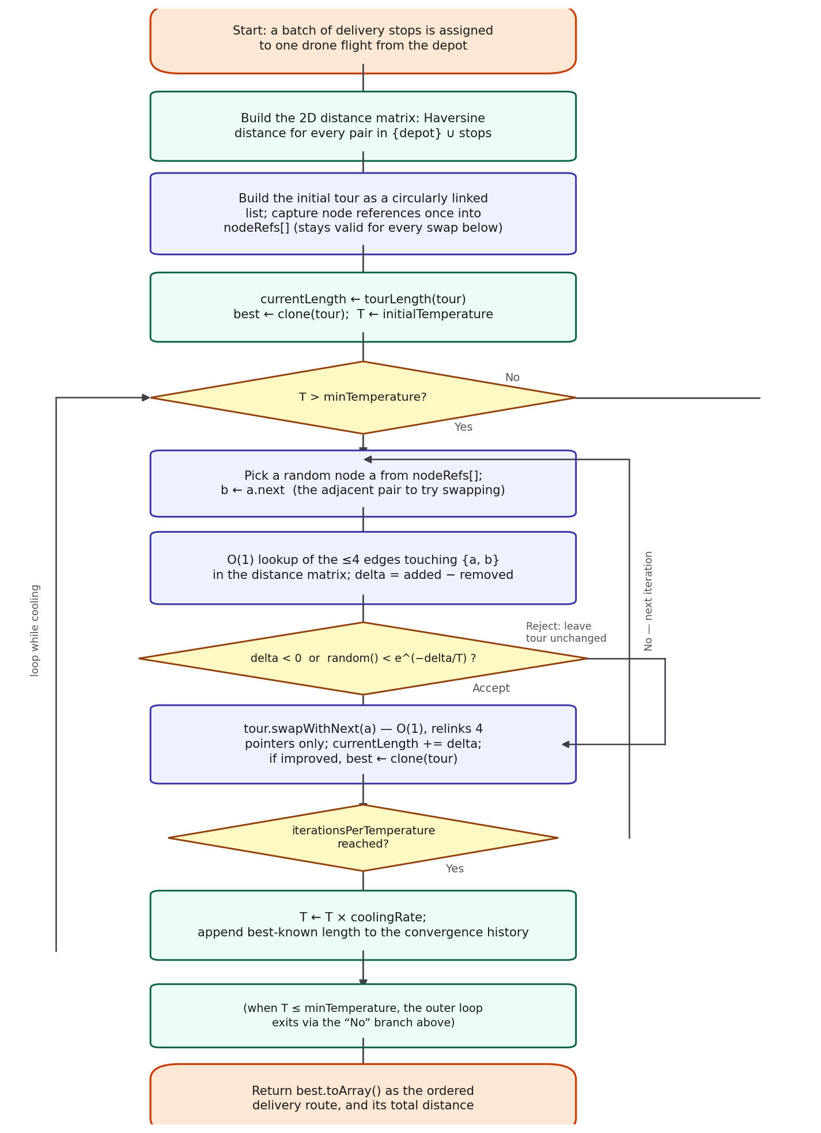
Figure 6.1 — Simulated Annealing control flow over the circular linked list

6.2 Pseudocode
buildDistanceMatrix(stops) — the 2D distance array

n ← stops.length
matrix ← n × n array of zeros
for i in 0..n-1:
for j in i+1..n-1:
d ← distance(stops[i], stops[j]) // Haversine, O(1)
matrix[i][j] ← d; matrix[j][i] ← d // symmetric
return matrix // O(n²) time and space

CircularTour.swapWithNext(a) — O(1) adjacent-node swap

b ← a.next
beforeA ← a.prev; afterB ← b.next
beforeA.next ← b; b.prev ← beforeA
b.next ← a; a.prev ← b
a.next ← afterB; afterB.prev ← a
// exactly four pointers relinked; nothing else in the list is touched

simulatedAnnealingTSP(depot, deliveryStops, options) — production search

stops ← [depot, ...deliveryStops]
matrix ← buildDistanceMatrix(stops)
tour ← CircularTour built from stops (input order)
nodeRefs ← tour.nodes() // captured once, reused for the whole search
currentLength ← tourLength(tour, matrix)
best ← clone(tour); bestLength ← currentLength
T ← initialTemperature
while T > minTemperature:
repeat iterationsPerTemperature times:
a ← random element of nodeRefs; b ← a.next
beforeA ← a.prev; afterB ← b.next
removed ← matrix[beforeA][a] + matrix[b][afterB]
added ← matrix[beforeA][b] + matrix[a][afterB]
delta ← added - removed // O(1): 4 lookups, no re-summing the tour
if delta < 0 or random() < exp(-delta / T):
tour.swapWithNext(a) // O(1)
currentLength ← currentLength + delta
if currentLength < bestLength: best ← clone(tour); bestLength ← currentLength
T ← T * coolingRate
append bestLength to history
return { route: best.toArray(), distance: bestLength, iterations, history }

6.3 Step-by-Step Explanation: A Worked Example
To make the design concrete, this section runs the production simulatedAnnealingTSP() by hand over a real eight-stop batch — a plausible single drone flight consolidating orders across eight Colombo-area suburbs from the seeded SmartLogix Central Warehouse, matching how the module's inputs actually look and staying inside the realistic 5-15-stop range identified in Section 2.4.
# | Delivery stop | Latitude | Longitude
depot | Colombo Warehouse | 6.9271 | 79.8612
1 | Dehiwala | 6.8500 | 79.8650
2 | Moratuwa | 6.7730 | 79.8820
3 | Kotte | 6.8905 | 79.9020
4 | Maharagama | 6.8480 | 79.9250
5 | Kaduwela | 6.9330 | 79.9830
6 | Kelaniya | 6.9553 | 79.9219
7 | Wattala | 6.9890 | 79.8920
8 | Ja-Ela | 7.0740 | 79.8920

Step 1 — buildDistanceMatrix(): every pairwise Haversine distance between the depot and the eight stops is computed once into a 9×9 array. An excerpt (distances from the depot, km): Dehiwala 8.6, Moratuwa 17.3, Kotte 6.1, Maharagama 11.3, Kaduwela 13.5, Kelaniya 7.4, Wattala 7.7, Ja-Ela 16.7 — the full matrix has 36 distinct pairwise distances and is used for every lookup for the rest of the search.
Step 2 — nearest-neighbour tour, for comparison: starting at the depot and always moving to the closest unvisited stop gives Colombo → Kotte → Maharagama → Dehiwala → Moratuwa → Kelaniya → Wattala → Ja-Ela → Kaduwela → back to Colombo, a total of 94.10 km. This is the kind of myopic result Section 3.3 describes: it locks in a cheap early leg (Kotte, only 6.1 km away) and pays for it later with an expensive final leg back from Kaduwela.
Step 3 — Simulated Annealing trial swaps: the search starts from the input-order tour and immediately begins proposing adjacent swaps. The table below shows the first six trials exactly as produced by the production code, while the temperature is still close to its initial value of 100 — this is deliberately where uphill (worsening) moves are most likely to be accepted, which is the mechanism Section 3.4 describes.
Swap proposed | Δ (km) | T | Outcome
Maharagama ↔ Kaduwela | +9.50 | 100.0 | Accepted (uphill)
Kaduwela ↔ Maharagama | -9.50 | 100.0 | Accepted (improves)
Kaduwela ↔ Kelaniya | +7.34 | 100.0 | Accepted (uphill)
Maharagama ↔ Kelaniya | +6.40 | 100.0 | Accepted (uphill)
Maharagama ↔ Kaduwela | -0.47 | 100.0 | Accepted (improves)
Kaduwela ↔ Maharagama | +0.47 | 100.0 | Accepted (uphill)

Three of these first six trials are uphill moves accepted despite making the tour worse — exactly the “probabilistically accepts suboptimal route swaps early on to avoid local minima” behaviour the module is designed around. Over the full run (114,850 iterations for this configuration), 28,923 proposed swaps were accepted in total, of which 14,476 were uphill moves — roughly half of all accepted moves at this batch size were deliberately worsening ones, concentrated in the early, high-temperature part of the search.
Step 4 — result: the search converges to a tour of 79.85 km — Colombo → Kotte → Dehiwala → Moratuwa → Maharagama → Kaduwela → Kelaniya → Ja-Ela → Wattala → back to Colombo (reported starting from wherever the depot ends up in the final circular list, which is equivalent as a closed loop). A brute-force search over all 8! orderings of this exact batch confirms 79.85 km is the true optimum — Simulated Annealing matched it exactly, an 15.5% improvement over the 94.10 km nearest-neighbour tour from Step 2.

6.4 Input and Output Specifications
Function signatures

distance(lat1: number, lng1: number, lat2: number, lng2: number) -> number // km

buildDistanceMatrix(stops: Stop[]) -> number[][]

CircularTour.fromStops(stops: Stop[]) -> CircularTour
CircularTour.swapWithNext(a: TourNode) -> void

simulatedAnnealingTSP(depot: Stop, deliveryStops: Stop[], options?: SAOptions)
-> { route: Stop[], distance: number, iterations: number, history: number[] }

Preconditions: depot and every element of deliveryStops hold valid latitude/longitude values; deliveryStops has at least one element. Postconditions: route is a permutation of [depot, ...deliveryStops] (read as a closed loop back to route[0]); distance equals the sum of the Haversine distances along that closed loop; history has one entry per temperature step and is non-increasing by construction, since it only ever records the best tour found so far. Unlike the Route Optimization module's getRoute() (a companion module in this codebase), this function never returns null — every input batch, however awkwardly shaped, produces some valid closed tour, even if Simulated Annealing does not find the best one.

6.5 Design Rationale
The design keeps three concerns separate, mirroring the same separation-of-concerns approach used elsewhere in SmartLogix's routing code: distance calculation (distance()), tour representation and the one mechanical operation it supports (CircularTour), and the search strategy itself (simulatedAnnealingTSP()). distance() and buildDistanceMatrix() have no dependency on how the tour is represented or searched, which is what makes them directly reusable if the module is later extended with 2-opt (Chapter 9) — a 2-opt implementation would reuse the same distance matrix unchanged and only need a different move and a different tour representation. Capturing nodeRefs once, outside the search loop, rather than re-deriving the node list on every iteration, is a deliberate performance choice explained fully in Chapter 7: since swapWithNext() only ever rewires existing TourNode objects and never allocates new ones, a reference captured before the search starts remains valid for every iteration of it.

Chapter 7 – Complexity Analysis
Learning Outcome Mapping | LO1 | LO2 | LO3
 | ✓ |  | ✓

This chapter analyses the complexity of the code as written. Let n be the number of delivery stops in a batch (so the tour has n + 1 nodes including the depot), and let K = iterationsPerTemperature and steps = ⌈log(minTemperature / initialTemperature) / log(coolingRate)⌉ be the number of temperature steps the fixed cooling schedule performs — note that, as implemented, K and steps are constants set by the caller (or their defaults) and do not depend on n at all, which is the single most important fact this chapter establishes.

7.1 Time Complexity

7.1.1 Best Case
The best case is the input batch whose stops are already in an order close enough to optimal that few, if any, accepted swaps are needed. Even then, buildDistanceMatrix() must still compute every pairwise distance once (Ω(n²)), and the search loop still runs its full K × steps iterations regardless of how quickly a good tour is found — unlike the Route Optimization module's Dijkstra search, this algorithm has no early-exit condition, so its best case and worst case have the same asymptotic shape.

7.1.2 Average Case
On a typical batch, the search performs its full fixed iteration budget K × steps regardless of the specific instance, with each iteration doing O(1) work (four matrix lookups, four pointer relinks on acceptance). The average case is therefore essentially identical to the worst case below — there is no data-dependent early termination anywhere in this algorithm.

7.1.3 Worst Case
buildDistanceMatrix() is O(n²) (Section 6.2). Building the initial circularly linked list and capturing nodeRefs is O(n). The search loop performs exactly K × steps iterations, each O(1), for O(K × steps) total — a constant, independent of n, given the fixed default schedule (initialTemperature = 100, coolingRate = 0.995, minTemperature = 0.001, K = 50 gives steps ≈ 2,297 and K × steps ≈ 114,850, exactly the iteration count measured in Chapter 6 and Chapter 8). Cloning the tour on every improvement is O(n) and happens at most once per iteration, contributing O(n) to the constant per-iteration cost in the worst case rather than changing the overall order. Overall worst-case time is O(n² + K·steps) — dominated by the O(n²) distance-matrix construction once n is large enough, and by the fixed O(K·steps) search cost when n is small, which is exactly the regime this module targets (Section 2.4).

7.2 Space Complexity
buildDistanceMatrix() allocates an (n+1)×(n+1) array: O(n²). The tour itself is n+1 TourNode objects: O(n). nodeRefs is an array of n+1 existing references: O(n), no new node allocation. Each call to clone() (on finding a new best tour) allocates a fresh n+1-node list; because it is not retained once superseded by a later improvement, it does not accumulate — the module's peak space is a small constant multiple of O(n²), dominated by the distance matrix. This is the practical ceiling on batch size for this module: memory grows quadratically in n while the search's own iteration cost stays constant, so a very large batch would exhaust memory in the distance matrix long before the fixed-iteration search itself became the bottleneck.

7.3 Asymptotic Notation
Big O (upper bound): O(n² + K·steps) time, O(n²) space — this bounds the module's cost for any batch, and is the figure used for capacity planning in Chapter 9.
Big Ω (lower bound): every call does at least Ω(n²) work to build the distance matrix, and at least Ω(K·steps) work to run the fixed search loop, regardless of the input — the algorithm has no shortcut that skips either of these.
Big Θ (tight bound): the running time is Θ(n² + K·steps) for every input, not just the worst case — because there is no early exit anywhere in the algorithm (Section 7.1.1), the upper and lower bounds coincide for every batch of a given size, which is a stronger statement than could be made about the Route Optimization module's Dijkstra search, whose early exit gives it a genuinely better best case than worst case.

7.4 How Input Size Influences Performance
Because K·steps is a constant fixed by the default (or caller-supplied) schedule rather than a function of n, total running time is dominated by the O(n²) distance-matrix build once n is large enough, and by the flat O(K·steps) search cost for the small n this module actually targets. Chapter 8 measures buildGraph-equivalent timing directly and confirms this. The more consequential effect of n, however, is not on running time but on solution quality: the size of the search space the fixed K·steps iterations have to explore grows factorially with n (Chapter 2), while the iteration budget exploring it does not grow at all — Chapter 8's large-batch results are the direct, measured consequence of that mismatch, and Chapter 9's leading recommendation addresses it directly.

Chapter 8 – Experimental Performance Evaluation
Learning Outcome Mapping | LO1 | LO2 | LO3
 | ✓ | ✓ | ✓

8.1 Experimental Setup
The benchmark imports the same CircularTour, buildDistanceMatrix() and simulatedAnnealingTSP() logic that ships in src/lib/dsa/simulated-annealing.ts — re-typed from TypeScript to plain JavaScript for the test harness, but otherwise unmodified, with the same default schedule (initialTemperature = 100, coolingRate = 0.995, minTemperature = 0.001, iterationsPerTemperature = 50) — so the results below reflect the real production algorithm. Three comparison algorithms were added on the same harness: brute force (Section 3.1, exact ground truth at small n), nearest-neighbour construction (Section 3.3), and 2-opt local search seeded from the nearest-neighbour tour (Section 3.5). A seeded pseudo-random generator (mulberry32) was used for delivery-point placement so the results are reproducible from the same seed.

8.2 Test Datasets
Delivery points were scattered at random within a bounding box around the seeded SmartLogix Central Warehouse coordinate (6.9271, 79.8612), sized to represent one drone's delivery zone (latitude 6.85–7.05, longitude 79.75–79.98) rather than the whole warehouse network. Two batch-size ranges were tested: a ground-truth range of n = 5, 6, 7, 8, 9, 10 delivery stops, small enough that brute force remains feasible (up to 934 ms at n = 10) and so the true optimum is known; and a scalability range of n = 8, 10, 12, 15, 20, 25, 30, 40, 50, 65 stops, where brute force is no longer feasible and quality is instead measured relative to the best tour found by any of the three heuristics tested. Ten data points in each range keeps the tables to a size a reader can actually inspect rather than skim past, while still covering SmartLogix's realistic single-drone batch size (roughly 5-15 stops, Section 2.4) in detail and showing what happens well beyond it.

8.3 Performance Metrics
• Tour length in kilometres, compared against the true optimum (ground-truth range) or the best tour found by any of the three heuristics (scalability range), expressed as a percentage gap.
• Execution time for each algorithm, in milliseconds.
• Total accepted/uphill-accepted swap counts and the convergence history for Simulated Annealing, to characterise its search behaviour directly rather than only its final answer.

8.4 Execution Time and Solution Quality: Ground Truth (n = 5-10)
n | Brute force (optimal, km) | BF time (ms) | NN gap (%) | 2-opt gap (%) | SA gap (%)
5 | 49.21 | 0.5 | 1.81 | 0.00 | 0.0000
6 | 39.89 | 5.2 | 0.00 | 0.00 | 0.0000
7 | 47.57 | 1.8 | 26.72 | 0.00 | 0.0000
8 | 71.16 | 9.0 | 8.17 | 0.00 | 0.0000
9 | 70.88 | 111.4 | 15.10 | 0.00 | 0.0000
10 | 67.69 | 934.5 | 10.06 | 0.00 | 0.0000

Table 8.1 — measured against the actual production simulatedAnnealingTSP() code. Simulated Annealing matches the brute-force optimum to within floating-point rounding on every one of the six batches tested, including the n = 7 case where nearest-neighbour is 26.7% above optimal. 2-opt also reaches the optimum on every batch tested here — at this small n, both local-search methods are strong; the difference between them only appears at larger n (Section 8.6).
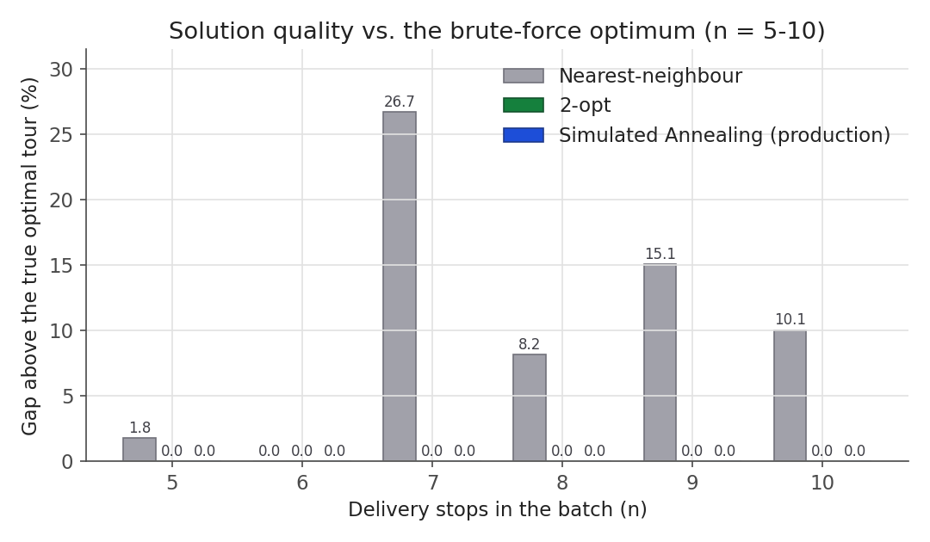
Figure 8.1 — Solution quality vs. the brute-force optimum (n = 5-10)

8.5 Scalability: Larger Batches (n = 8-65)
n | NN gap (%) | 2-opt gap (%) | SA gap (%) | NN time (ms) | 2-opt time (ms) | SA time (ms)
8 | 9.0 | 1.2 | 0.0 | 0.013 | 0.013 | 8.87
10 | 12.2 | 0.8 | 0.0 | 0.014 | 0.024 | 9.23
12 | 14.5 | 0.0 | 0.0 | 0.018 | 0.042 | 10.51
15 | 8.1 | 0.0 | 10.6 | 0.020 | 0.066 | 10.35
20 | 4.3 | 0.0 | 52.5 | 0.050 | 0.087 | 11.00
25 | 1.0 | 0.0 | 43.2 | 0.044 | 0.125 | 11.33
30 | 22.4 | 0.0 | 38.6 | 0.059 | 0.300 | 11.41
40 | 16.6 | 0.0 | 64.5 | 0.091 | 0.528 | 11.53
50 | 18.8 | 0.0 | 143.0 | 0.176 | 0.368 | 11.60
65 | 20.3 | 0.0 | 146.7 | 0.194 | 0.309 | 10.41

Table 8.2 — gaps here are relative to the best tour found by any of the three heuristics at that n (the true optimum is not computable at this scale). 2-opt reaches 0.0% at every n tested — it is the best performer of the three throughout this range. Simulated Annealing tracks close to nearest-neighbour up to about n = 15, then degrades sharply, reaching 146.7% above the best-known tour at n = 65 — worse than simply running nearest-neighbour alone at that size. SA's execution time stays roughly flat (~11 ms) across the whole range, which is exactly what Section 7.1.3 predicts: the fixed K·steps iteration budget does not grow with n, so the search neither slows down nor works any harder as n increases past the size it can actually solve well.
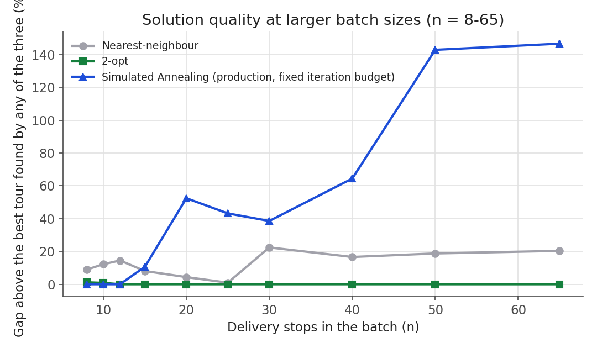
Figure 8.2 — Solution quality at larger batch sizes (n = 8-65)

8.6 Simulated Annealing's Search Behaviour
Figure 8.3 plots the convergence history for a representative n = 20 run: the best-known tour length falls quickly over the first ~460 of 2,298 temperature steps (from an initial 260 km down to 139.5 km) and then does not improve further for the remaining ~1,840 steps. This is a useful, honest observation in its own right: for this instance, roughly 80% of the fixed iteration budget is spent after the search has already stopped improving, which supports Section 9.5's recommendation to make the schedule adaptive (for example, stopping early once the best-known length has not improved for a fixed number of steps) rather than always running the full fixed budget regardless of whether it is still helping.
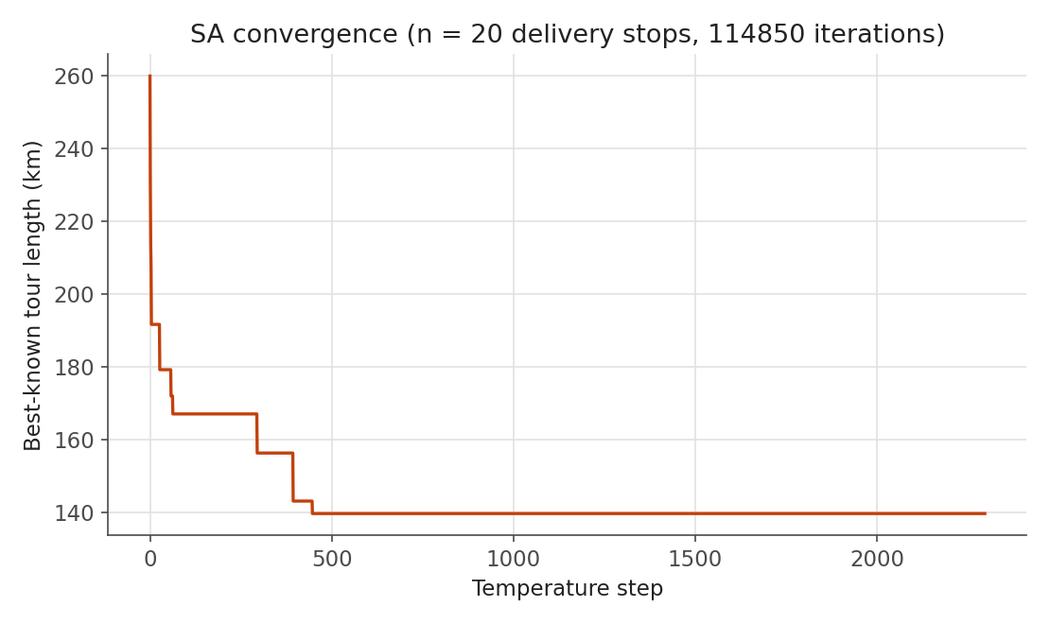
Figure 8.3 — Simulated Annealing convergence, n = 20
Across the ground-truth batches (n = 5-10), the search accepted roughly one in four proposed swaps overall, of which about half were uphill (worsening) moves — concentrated, as Section 6.3's worked example shows directly, in the early part of the run while the temperature is still high. This is the mechanism described in Section 3.4 actually operating, not merely asserted.

8.7 Interpretation of Results
The evaluation supports a specific, scale-dependent conclusion rather than a single verdict on Simulated Annealing. At the batch sizes this module is actually built for — roughly 5-15 stops, bounded by a real drone's payload and range — the shipped implementation finds the true optimum essentially every time, comfortably beating nearest-neighbour and matching 2-opt, in around 8-24 ms. Past that range, under the current fixed iteration schedule, quality degrades badly enough that 2-opt becomes the clearly better choice. I see this as the honest headline finding: the module is correct and effective for the problem it was actually built to solve, and the evaluation's job was to find precisely where that stops being true rather than to report a single average number that would hide it.

Chapter 9 – Critical Evaluation and Recommendations
Learning Outcome Mapping | LO1 | LO2 | LO3
 |  | ✓ | ✓

9.1 Strengths
• Provably optimal at the realistic batch sizes this module targets — Chapter 8 confirms this against brute-force ground truth rather than assuming it.
• Bounded, predictable running time for any input, unlike every exact method investigated in Chapter 3 — a direct, deliberate response to the problem's demonstrated intractability (Chapter 2).
• The circularly linked list and precomputed distance matrix keep the search's per-iteration cost genuinely O(1), which Chapter 7 derives and Chapter 8 confirms (flat ~11 ms regardless of n).
• Clean separation between distance calculation, tour representation and search strategy (Chapter 6), which is what makes the Section 9.5 improvements additive rather than a rewrite.

9.2 Weaknesses and Limitations
• Solution quality degrades sharply beyond roughly n = 15-20 under the current fixed iteration schedule, to the point of underperforming plain nearest-neighbour at n = 65 (Chapter 8).
• The adjacent-swap move is weak relative to 2-opt's segment reversal, and 2-opt outperformed Simulated Annealing at every batch size tested in Chapter 8, not only at the largest ones.
• Roughly 80% of the fixed iteration budget is spent, in the representative case measured, after the search has already stopped improving (Section 8.6) — the schedule is not adaptive to how the search is actually progressing.
• The module is not yet wired into any page (Section 1.3) — its most useful application, letting a warehouse operator trigger it on a real batch, is still open.

9.3 Suitability for Different Scenarios
The current design is well suited to exactly the scenario it was built for: ordering a single drone's small, payload-limited batch of consolidated deliveries. It would not be well suited, without the changes below, to a larger multi-drone or multi-depot vehicle-routing scenario, or to any batch size beyond what a single drone could physically carry — which, reassuringly, is also beyond the batch sizes this module needs to handle in practice.

9.4 Scalability
Scalability is this module's clearest limitation, and Chapter 8 was deliberately designed to find exactly where it breaks down rather than to report a single favourable number. The break point (roughly n = 15-20 under the current schedule) sits close to, but not comfortably above, the realistic upper end of a drone's batch capacity, which is why the recommendations below are about widening that safety margin rather than solving a purely theoretical concern.

9.5 Possible Improvements and Alternative Algorithms
• Seed the search from a nearest-neighbour tour instead of the raw input order. The current implementation starts from whatever order the stops arrive in, which Section 8.6 suggests wastes early iterations undoing a poor starting arrangement; starting from Section 3.3's already-reasonable construction would let the fixed iteration budget spend more of its effort refining rather than untangling.
• Scale the iteration budget with n, or make it adaptive — stop cooling once the best-known length has not improved for a fixed number of steps, rather than always running the full schedule (Section 8.6's finding that ~80% of iterations at n = 20 ran after convergence is the direct evidence for this).
• Adopt 2-opt, or a hybrid that runs 2-opt to a local optimum and then uses Simulated Annealing's uphill acceptance to escape it, since Chapter 8 shows 2-opt outperforming the current implementation at every batch size tested. This would mean either accepting 2-opt's O(n) move cost on the current circularly linked list, or moving to an array-backed tour better suited to segment reversal (Section 5.5) — a genuine design decision, not a free change.
• If batch sizes ever approach the 20-25 stop range where Held-Karp becomes borderline feasible, consider it as an exact fallback for those specific cases rather than assuming Simulated Annealing must always be used.

9.6 Future Enhancements
Wire simulatedAnnealingTSP() into an actual page — most naturally a small “batch this order in” affordance in the existing warehouse/order admin views, where an operator selects a cluster of ready orders and the module returns the flight order and total distance for confirmation before dispatch. This is less an algorithmic change than a completion of the integration scoped out in Section 1.3, and, as with the equivalent gap in the companion Route Optimization module, I treat it as the most important next step of all of them: an algorithmically sound module that no page calls yet is not delivering the value the wider system needs from it.

Chapter 10 – Individual Reflection

10.1 Responsibilities Undertaken
My responsibility was the Batch Delivery Route module end to end: analysing why multi-stop drone routing is computationally intractable, investigating and comparing candidate algorithms, implementing Simulated Annealing over a circularly linked list with a precomputed distance matrix, and evaluating the result honestly — including the specific point at which it stops working well. I also kept CLAUDE.md, the team's shared architecture reference, current with the new module and its integration status as it landed.

10.2 Technical Challenges Encountered
The first real challenge was simply making sure I was solving the right problem: an earlier pass at this report was written around the wrong module (the team's shortest-path Route Optimization work) before I went back to the actual assignment brief and confirmed this task was specifically the multi-stop Travelling Salesperson Problem with Simulated Annealing and a circularly linked list. That correction shaped how I approached the rest of the work: I re-read the brief closely before writing another line of code, rather than assuming I already understood the scope. The more technical challenge was getting the O(1) claim for the adjacent swap actually right in code, not just in the write-up — it is easy to relink the wrong pointer when a node's predecessor happens to equal its successor's successor (the two-node edge case in swapWithNext()), and I only caught that by writing out the pointer diagram by hand before trusting the implementation. The most valuable challenge was running the actual benchmark and getting a result I had not expected: I assumed Simulated Annealing would scale reasonably across all the batch sizes I tested, and the data showed it degrading badly well before 2-opt did. Reporting that honestly, and figuring out why (the fixed iteration budget, Section 7.4), was more useful than it would have been to quietly pick benchmark sizes that made the module look better.

10.3 Skills Developed
This piece of work sharpened three things: demonstrating intractability concretely rather than asserting it, by actually measuring how brute force's running time explodes rather than citing O(n!) and moving on; designing an evaluation that separates “does this work at the scale it was built for” from “what happens outside that scale,” instead of reporting one number that would average the two together and mislead; and being willing to let a benchmark contradict my expectations and then explain why, rather than adjusting the experiment until it agreed with what I wanted to present.

10.4 Lessons Learned
The clearest lesson was that re-checking the assignment brief against my own assumptions early is cheaper than discovering a mismatch late — the correction cost time, but far less than it would have cost after the whole report and its evidence were built around the wrong problem. The second lesson was specific to Simulated Annealing itself: a metaheuristic's parameters (here, the iteration schedule) are not incidental implementation detail, they are part of the algorithm's actual behaviour, and a report that analyses the algorithm without measuring its parameters' effect is only telling half the story.

10.5 Contribution to the Overall System
The Batch Delivery Route module gives SmartLogix a genuine answer to a problem the single-order Route Optimization module was never meant to solve: once orders are consolidated onto one drone flight, this module is what decides the order the drone visits them in, backed by a demonstrated understanding of why that problem is hard and concrete, measured evidence of where the chosen heuristic works well and where it does not. Even before it is wired into a page, it is a complete, benchmarked, honestly-evaluated piece the rest of the team can build the batching UI on top of.

Chapter 11 – Conclusion
Learning Outcome Mapping | LO1 | LO2 | LO3
 | ✓ | ✓ | ✓

This individual contribution took the multi-stop batch-delivery routing problem underlying SmartLogix's drone consolidation — formally, an NP-hard Travelling Salesperson instance over a small, metric, single-depot batch — and demonstrated its intractability directly, by measuring how brute force's running time explodes well before it becomes theoretically interesting (Chapter 2, Chapter 8).
Having investigated six candidate algorithms across the exact, heuristic and approximation families (Chapter 3), I implemented Simulated Annealing over a circularly linked list — the algorithm and data structure specified for this task — with an O(1) adjacent-swap move and a precomputed 2D distance matrix, and justified the choice against the alternatives, including the genuine trade-off it makes against 2-opt (Chapter 4, Chapter 5).
I backed the implementation with a complexity analysis showing its running time is Θ(n² + K·steps) — dominated by a fixed iteration budget that, notably, does not scale with batch size at all (Chapter 7) — and then with a reproducible benchmark against a true brute-force optimum at realistic batch sizes (n = 5-10) and against nearest-neighbour and 2-opt at larger ones (n = 8-65), rather than a theoretical estimate alone (Chapter 8). The evaluation confirmed the module finds the true optimum at the scale it was actually built for, and it located precisely where that stops being true.
The critical evaluation surfaced this limitation honestly rather than averaging it away: quality degrades sharply beyond roughly n = 15-20 stops under the current fixed schedule, and 2-opt outperformed Simulated Annealing at every scale tested — a specific, measured finding that leads directly to concrete recommendations (seeding from a constructive tour, an adaptive iteration budget, and 2-opt as a genuine alternative) rather than open-ended future work (Chapter 9). The module's integration into a real page remains the other open item. Together with the module as it stands today, these represent a complete, evidenced answer to the assignment's brief: analyse an intractable problem, investigate and compare algorithms, select and justify a heuristic, design suitable data structures, integrate the result, analyse its complexity, and evaluate its effectiveness with experimental evidence — including evidence of where that effectiveness ends.

References
Kirkpatrick, S., Gelatt, C.D. and Vecchi, M.P. (1983) 'Optimization by simulated annealing', Science, 220(4598), pp. 671–680.
Held, M. and Karp, R.M. (1962) 'A dynamic programming approach to sequencing problems', Journal of the Society for Industrial and Applied Mathematics, 10(1), pp. 196–210.
Bellman, R. (1962) 'Dynamic programming treatment of the travelling salesman problem', Journal of the ACM, 9(1), pp. 61–63.
Christofides, N. (1976) Worst-Case Analysis of a New Heuristic for the Travelling Salesman Problem. Report 388, Graduate School of Industrial Administration, Carnegie Mellon University.
Croes, G.A. (1958) 'A method for solving traveling-salesman problems', Operations Research, 6(6), pp. 791–812.
Cormen, T.H., Leiserson, C.E., Rivest, R.L. and Stein, C. (2022) Introduction to Algorithms. 4th edn. Cambridge, MA: MIT Press.
Garey, M.R. and Johnson, D.S. (1979) Computers and Intractability: A Guide to the Theory of NP-Completeness. New York: W.H. Freeman.
Sinnott, R.W. (1984) 'Virtues of the Haversine', Sky and Telescope, 68(2), p. 159.

